Contents of Share-point training

**Visual Studio Code** 3

Dev source code 3

1. Install SPGo from Extensions to get the source code from dev source 3

2. Create a new folder at File Explorer 3

3. Click on Add Workspace folder 4

4. Click on Setting Icon -> choose Command Palette… 4

5. Select Config – FTP connection setting 6

6. Enter the SP site URL 6

7. Select Retrieve folder and enter the path to folder 7

8. After changing anything, save and enter message to commit 8

**Atom** 9

Pre-prod source code: update master.css 9

1. Connect to ftp and get source code 9

**Visual Studio** 10

1. Get source code from source package on GitHub - https://github.com/niftit/NIFTIT.Branding.Synergy/ 10

2. Open source code by VS 10

3. Add all txt files to feeds folder 11

txt 11

5. All files css, js and images have to upload to cdn (PhiLac is responsible for this task) 12

**Using the source code and testing on SP site** 13

1. Visual Studio: 13

2. Share Point Online 14

Visual Studio Code

## Dev source code

Test on https://synergyflavors.sharepoint.com/sites/dev/SitePages/Home.aspx

1. Install SPGo from Extensions to get the source code from dev source

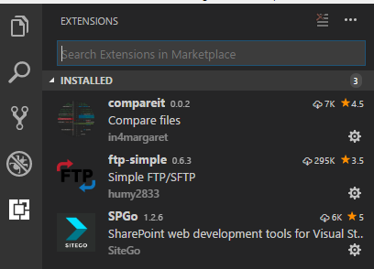

1. Create a new folder at File Explorer 
2. Click on Add Workspace folder

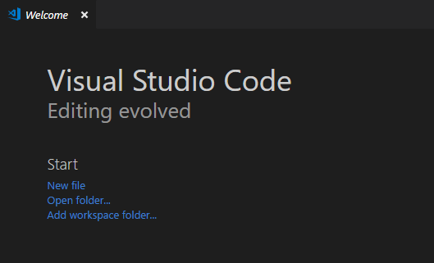

1. Click on Setting Icon -> choose Command Palette…

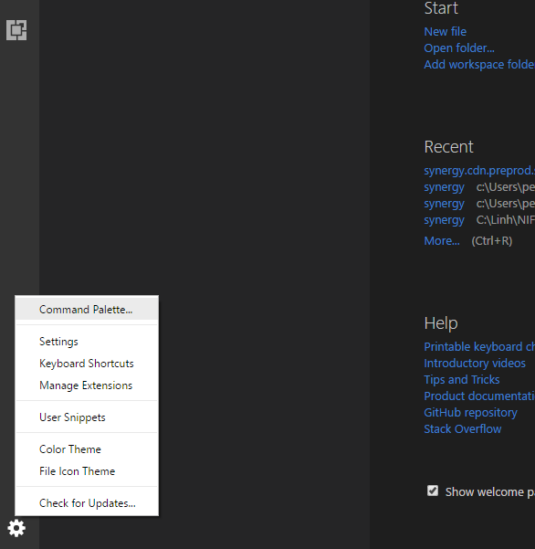

1. Select Config – SPGo Configure workspace

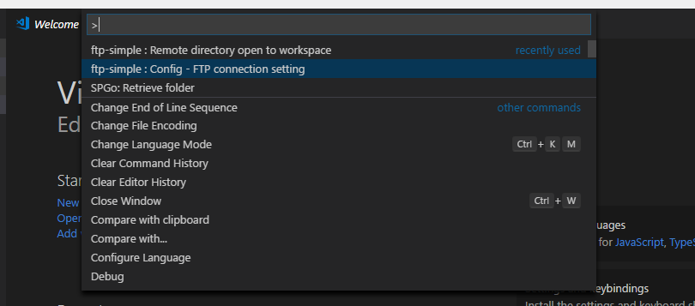

1. Enter the SP site URL

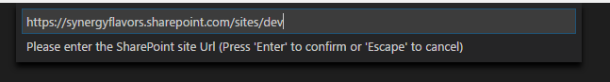

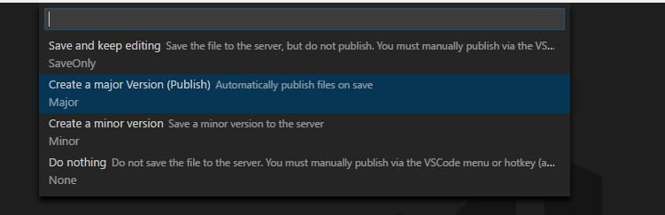

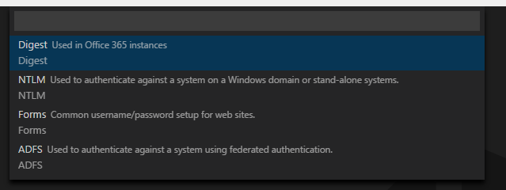

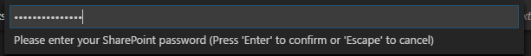

1. Select Retrieve folder and enter the path to folder

EX:   
/siteassets/CompanyBranding/  
/_catalogs/masterpage



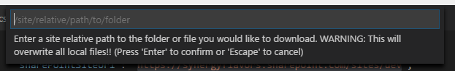

1. After changing anything, save and enter message to commit

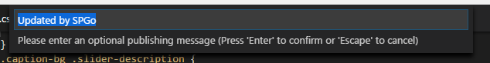

Atom

## Pre-prod source code: update master.css

1. Connect to ftp and get source code

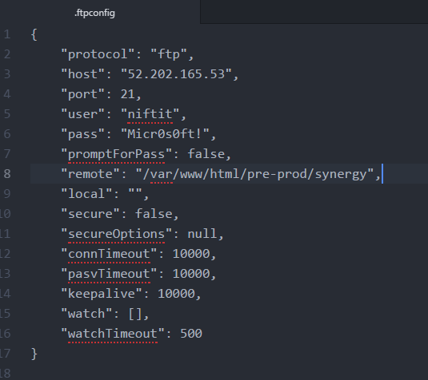

Visual Studio

1. Get source code from source package on GitHub - <https://github.com/niftit/NIFTIT.Branding.Synergy/>
2. Open source code by VS

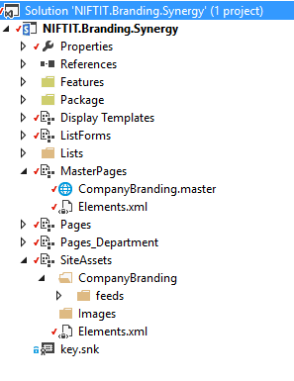

1. Add all txt files to feeds folder

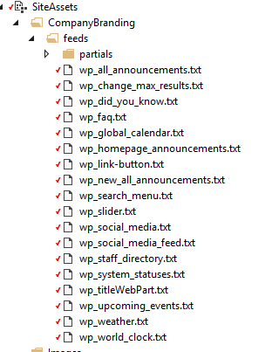

1. Change all the links (css, js and images) to cdn links

txt

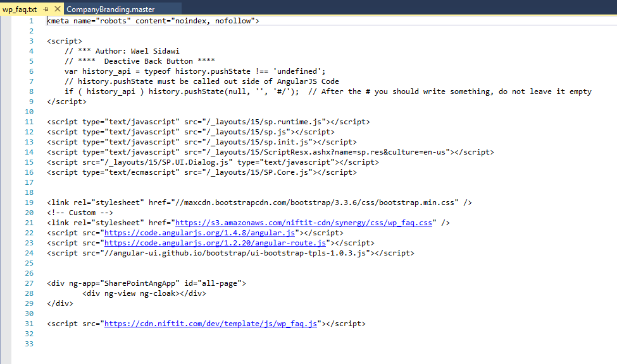

Css

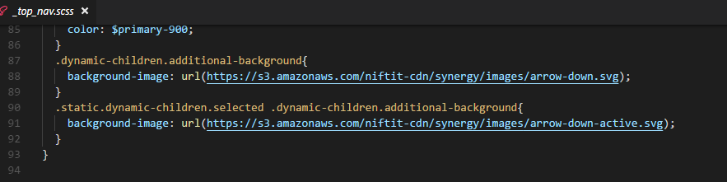

1. All files css, js and images have to upload to cdn (PhiLac is responsible for this task)

Using the source code and testing on SP site

1. Visual Studio:

* Select Build

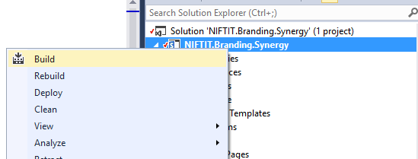

* Select Publish

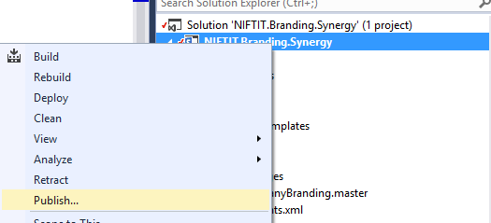

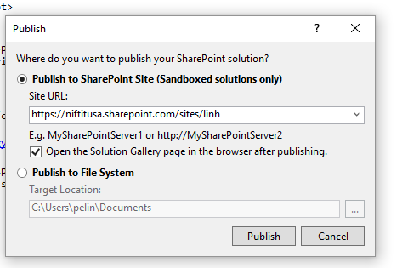

1. Share Point Online

EX: <https://niftitusa.sharepoint.com/sites/linh>

Activate resource:

* Site settings -> Solutions -> Activate

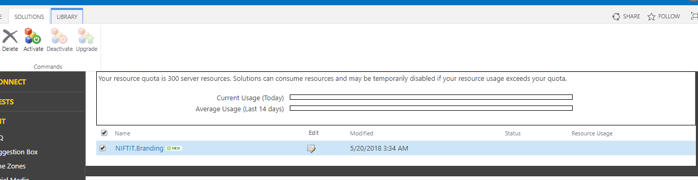

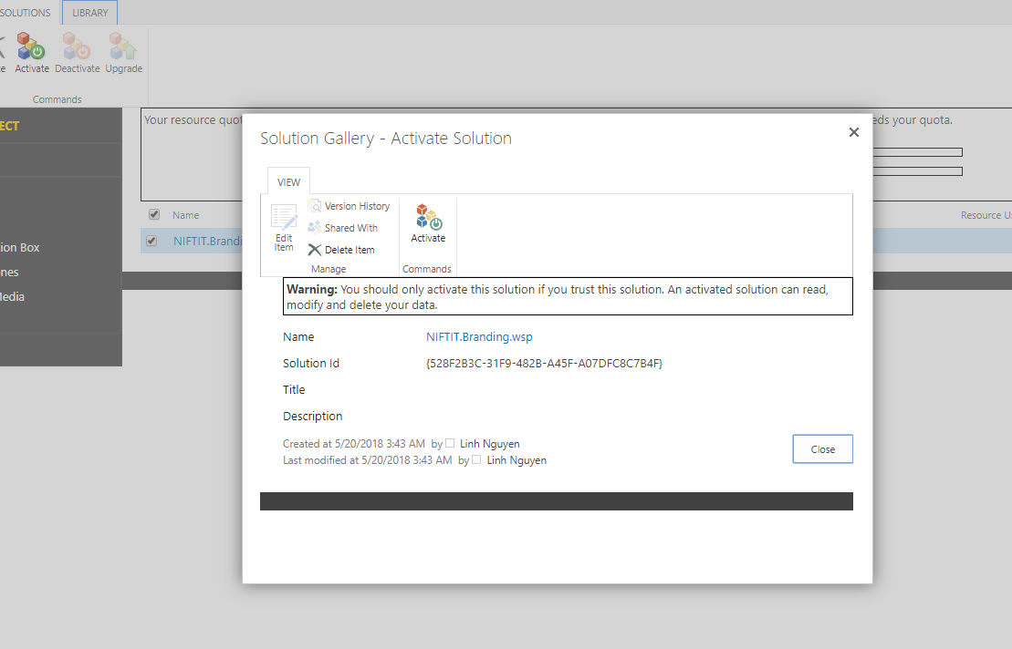

* Site settings -> Manage site features -> Activate NIFTIT.Branding.Data -> Activate NIFTIT.Branding.UI
* Site settings -> Master page -> choose master page

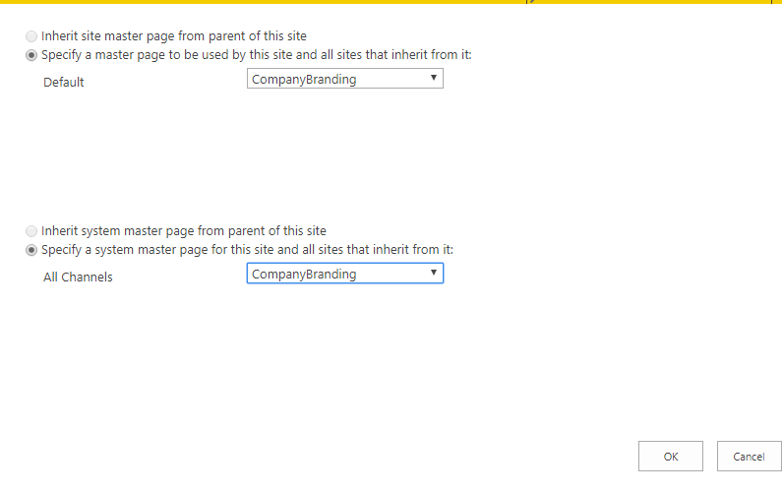

Deactivate resource:

* Site settings -> Manage site features -> Deactivate NIFTIT.Branding.UI -> Deactivate NIFTIT.Branding.Data
* Site settings -> Solutions -> Deactivate -> Delete

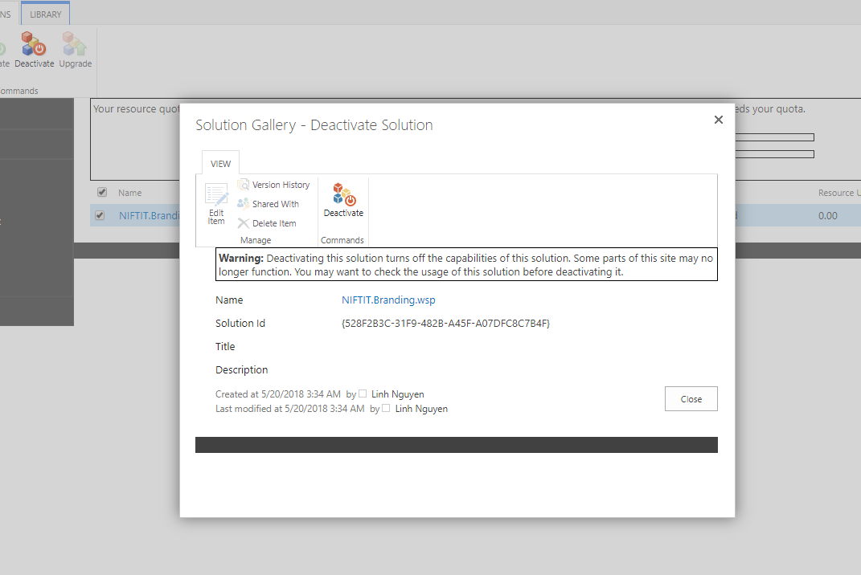

Add webpart

